**THIRUVALLUVAR COLLEGE OF ENGINEERING AND TECHNOLOGY**

**ARUNACHALA CITY,PONNUR HILLS,VANDAVASI-604 505**

**PROJECT TITLE:Tripadvisor E-Managemant**

**Presented by**

**BHARATH P (NM ID:** **D68FB2183A4828290C04AD9E1E594E5D**

**DHINESHKUMAR L(NM ID:6D5D4D7B56954E996B94C32D0F270E72)**

**DIVYA R(NM ID:** **231320E413A6735BA21492C6A2C444D8)**

**DURGA M(NM ID:** **34003035024A22E97884ECC8IF3F2671)**

**TRIPADVISOR E-MANAGEMENT**

**Project Overview:**

**The goal is to integrate TripAdvisor data (reviews, customer inquiries, ratings) into Salesforce for enhanced customer service, sales, and marketing. The integration can include:**

**1. Automated data sync between TripAdvisor and Salesforce using APIs.**

**2. Lead and opportunity management based on customer interactions.**

**3. Customer sentiment analysis using TripAdvisor reviews.**

**4. Automated workflows for case management and customer engagement.**

**Components:**

**1.salesforce CRM integration**

**2.Marketing automation**

**3.Analytics and reporting**

**4.Collaboration tools**

**5.Data migration and integration.**

**Diagram and Workflow:**

**1. TripAdvisor Data Collection**

**Reviews, Ratings, Inquiries from TripAdvisor are pulled through the TripAdvisor API.**

**2. Salesforce Integration (API or Middleware like MuleSoft) Middleware Integration (like MuleSoft) or direct API integration pulls the data from TripAdvisor and transfers it to Salesforce.**

**3. Data Storage in SalesforceThe collected data is stored in Salesforce (as custom objects like "TripAdvisor Reviews," "Customer Inquiries," etc.).**

**4. Sentiment Analysis (Optional)AI Tools like Salesforce Einstein analyze the sentiment of TripAdvisor reviews to categorize them as positive, neutral, or negative.**

**Automated Insights are generated for sales and service teams based on review sentiment.**

**5. Lead and Case Management**

**Leads can be created directly from TripAdvisor inquiries.**

**6. Reporting and Analytics(salesforce Reports and Dashboards display key metrics like customer satisfaction, average ratings, review trends, and lead conversion rates from TripAdvisor).**

**7. Customer Engagement**

**Automated Responses/Workflows are triggered for engagement:**

**Positive reviews:**

**Thank-you emails, promotions.**

**Negative reviews:**

**Case management and issue resolution workflows.**

**Marketing Cloud:**

**Personalized campaigns based on TripAdvisor insights.**

**8. Feedback Loop**

**The customer is engaged through feedback requests, emails, and surveys. Their responses are captured and fed back into Salesforce for continuous customer relationship management.**

**FLOW CONTROL:**

**Create 3 variable:**

**Variable>api name>fold>text>available for input**

**variable>api name>csld>text>available for input**

**variable>api name>discount>number**

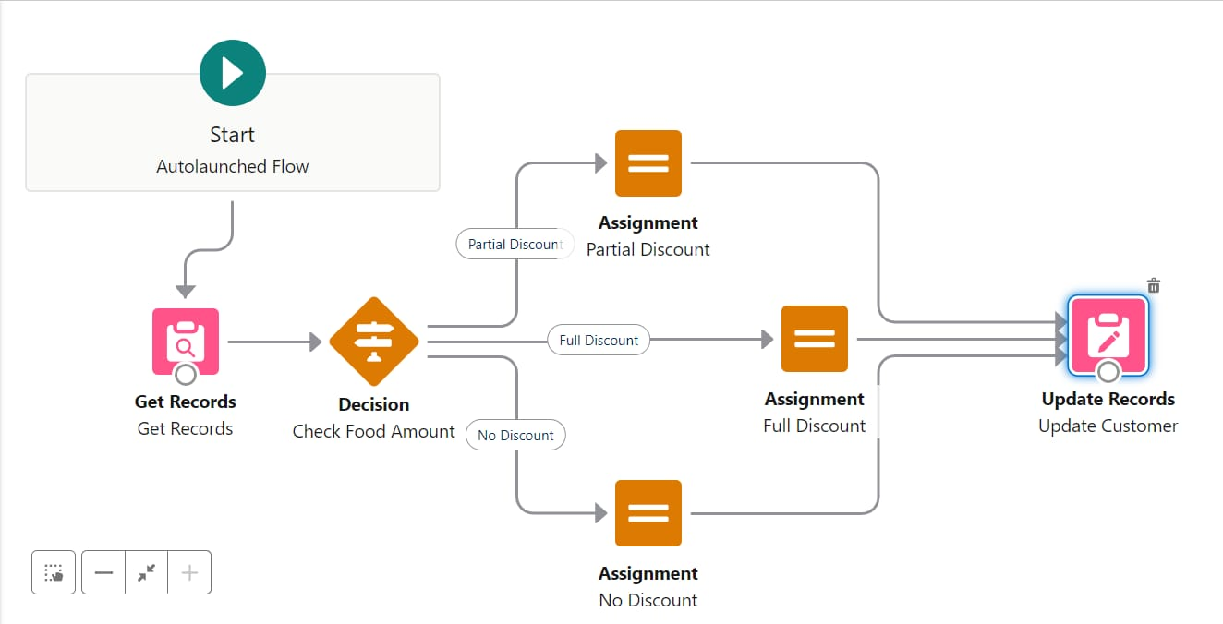

**2.DECISION ELEMENT :create 2 outcomes**

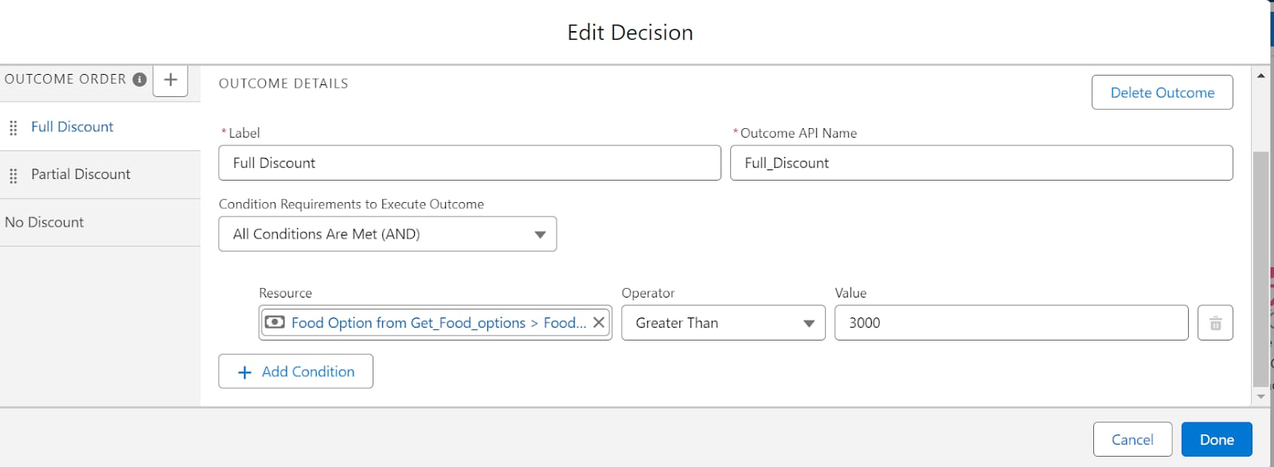

Take the 3 assignment>full discount,partial&no discount

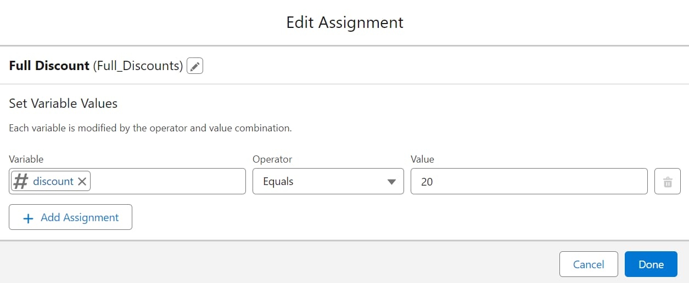

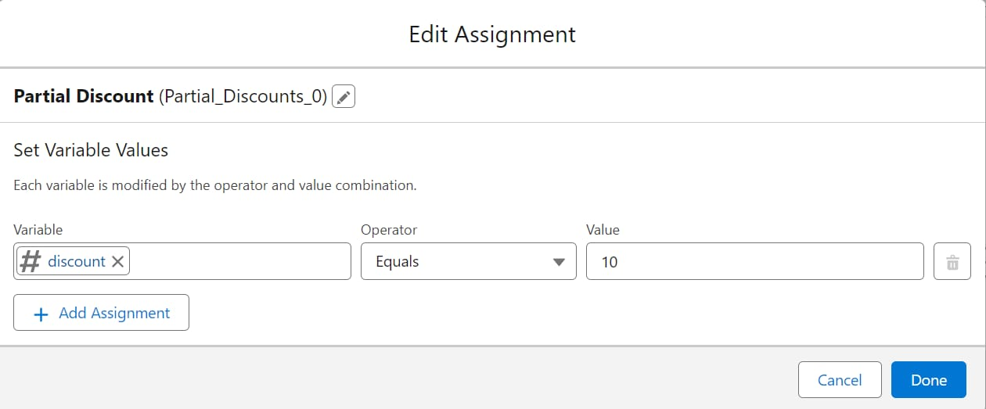

Apex trigger with handler:

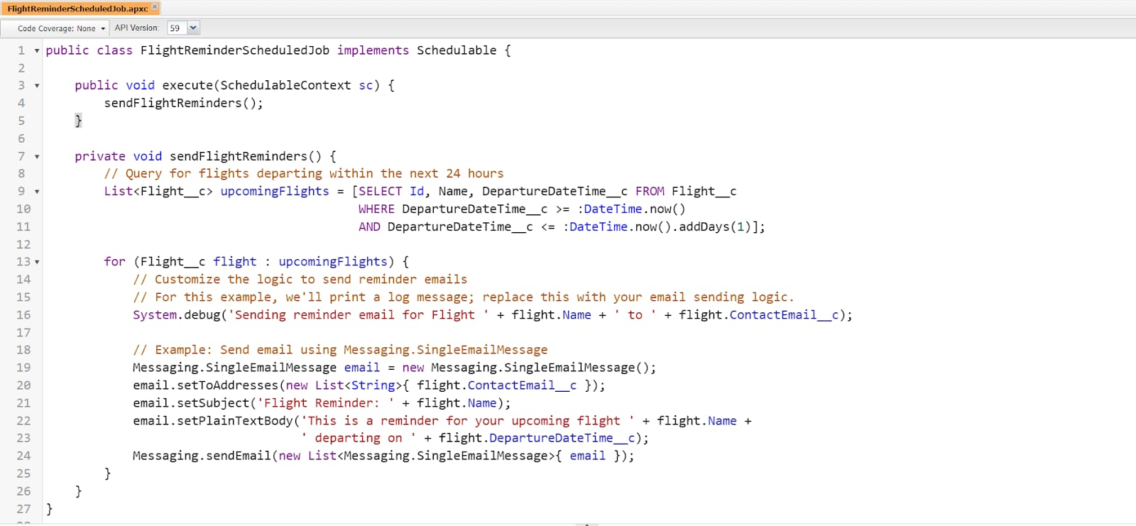

Trigger:

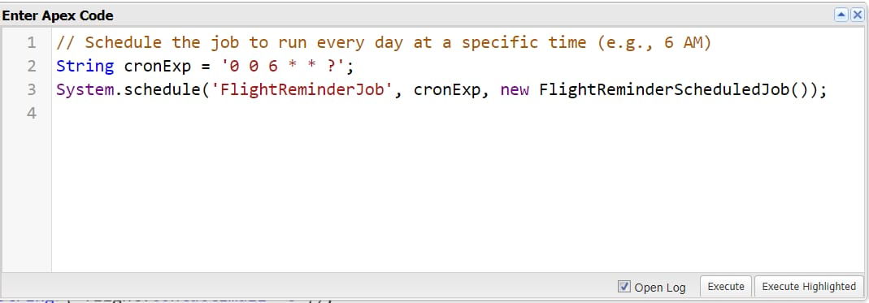

Conclusion:

This integration between TripAdvisor and Salesforce will streamline workflows, improve customer engagement, and provide actionable insights into customer sentiment, ultimately enhancing customer relationships and driving business growth. Let me know if you’d like additional details or a deeper dive into any specific part of the project!